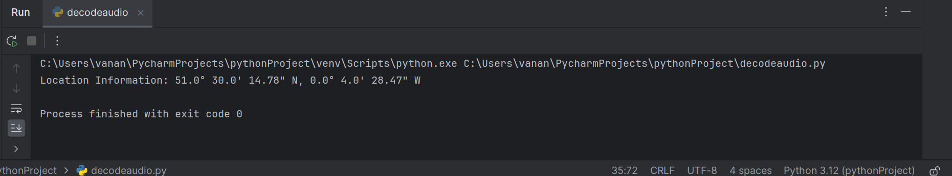

I have downloaded the image with meta data and had inserted the image with code and once after executing i got this output